Design document for TicTacToe

-By: Krishnapriya Hari and Namrata Keskar

# Class Diagrams

The game uses Object Oriented Design. The following are the main class of the program, and the relationships between the classes

## Class Relationships

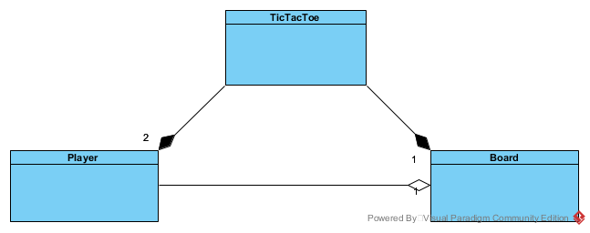

## TicTacToe

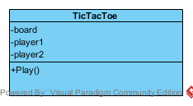

### Attributes of TicTacToe

board – Object of the class Board

player1 – object of the class Player representing the first player

player2 – object of the class Player representing the second player

### Methods of TicTacToe

play – Plays the TicTacToe game

## Board

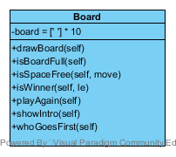

### Attributes of Board

board – This is a list of actual letters that form the board

### Methods of Board

drawBoard – draws the actual design of the Tic Tac Toe board

isBoardFull – checks if the board is full of letters or if there is any space available

isSpaceFree – given the player’s move and the board, it checks if the move the player wants to make is free

isWinner – uses the player’s letter and the board to check if the player has made a winning sequence

playAgain - asks players if they want to play the game again, gets called once the game ends

showIntro – asks the players if they want to display the introduction of the game. If the player answers Yes, then displays the introduction

whoGoesFirst - randomly chooses which player goes first

## Player

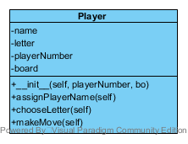

### Attributes of Player

name – name of the current player

letter – letter of the current player

playerNumber – player number of the player

board – the Board class object that a player has access to

### Methods of Player

__init__ - initializes the player object taking the player number and the board

assignPlayerName – asks the player to assign a name to their character and stores the name in the player object

chooseLetter – allows the randomly chosen player who goes first to choose their letter

makeMove - allows the players to make a move and checks if the move is valid